

**YEAR: 7**

**2018**

**SUBJECT: Science**

**TEST: Mixtures**

**TIME: 40 minutes**

**QUESTIONS: 10 Multiple Choice (10 marks)**

**6 Short Answer (20 marks)**

**TOTAL MARKS: 30 marks**

**DO NOT WRITE ON OR MARK THIS PAPER**

**SECTION ONE—MULTIPLE CHOICE** (10 marks)

This section has **10** questions. Answer **all** questions on the separate Multiple-choice Answer Sheet provided.

1. Which of the following is a pure substance?
2. cordial
3. soap
4. gold
5. salt water
6. Sugar dissolves easily in water, therefore sugar is said to be
7. insoluble
8. a solution
9. insolvent
10. soluble
11. Which beaker contains the most dilute solution?

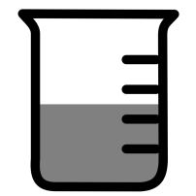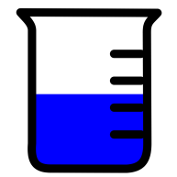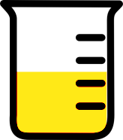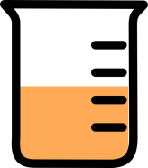

a) b) c) d)

1. Which of the following is insoluble in water?

a) sugar

b) copper sulfate

c) detergent

d) oil

1. When a large amount (but not the maximum amount) of a solute is dissolved in a solvent, the solution is called
2. saturated
3. concentrated
4. dilute
5. a suspension

6. A student wishes to obtain fresh water from salt water. The best way to do this is by:

1. filtration
2. evaporation
3. distillation
4. decanting

7. Which diagram represents a saturated solution?

= dissolved solid particle

= undissolved solid particle

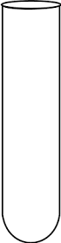

a) b) c) d)

8. Very heavy particles can most simply be separated from water by a process known as

a) purification

b) filtration

c) decantation

d) distillation

9. If you were planning to collect salt from sea water, which of the following pieces of apparatus would be of LEAST use?

a) filter funnel

b) evaporating basin

c) Bunsen burner

d) tripod stand

10. Consider the following diagram.



The apparatus drawn above represents the process of distillation. The changes occurring at **X** and **Y,** respectively, are

a) **X** – liquid 🡺 gas, **Y** – gas 🡺 liquid.

b) **X** – solid 🡺 liquid, **Y** – liquid 🡺 gas.

c) **X** – liquid 🡺 gas, **Y** – liquid is cooled.

d) **X** – liquid 🡺 gas, **Y** – gas is cooled.

**END OF MULTIPLE CHOICE SECTION**



**SEMESTER TWO 2018**

**Mixtures Test:**

**ANSWER BOOKLET**

**NAME:**

**FORM:** **DATE:**

Multiple Choice Short Answer Total

**/20**

**/10**

**/30**

**SECTION ONE:** Multiple choice answers

Cross (X) through the correct answer.

|  |  |  |  |  |
| --- | --- | --- | --- | --- |
| **1** | a | b | c | d |
| **2** | a | b | c | d |
| **3** | a | b | c | d |
| **4** | a | b | c | d |
| **5** | a | b | c | d |
| **6** | a | b | c | d |
| **7** | a | b | c | d |
| **8** | a | b | c | d |
| **9** | a | b | c | d |
| **10** | a | b | c | d |

**SECTION TWO: Short Answer (20 marks)**

Answer the questions in the spaces provided.

_____

1. a) Distillation is a much more difficult method than Evaporation. Why would people use distillation over evaporation? (1 mark)  
     
   ________________________________________________________________________  
     
   b) Filtration is a much slower method than Decantation. Why would people use filtration over decantation? (1 mark)  
     
   ________________________________________________________________________
2. Wax is a solid that does NOT dissolve in water.  
   Wax does dissolve in kerosene.  
   Sugar does dissolve in water.  
   Sugar does NOT dissolve in kerosene.  
   Kerosene does NOT dissolve in water (3 marks)

a) **Identify** the solvent you would use to make a solution containing wax.

_________________________________________________________________________________________________________________

b) **Identify** two substances that are insoluble in water.

___________________________________________________________________________________________________________________

c) **Identify** a substance that is soluble in water.

_____________________________________________________________________________________________________________________

1. When cooking rice it is important to wash the rice in water to remove the starch on the rice grains. After washing the rice the water is removed by pouring off the water.   
   What type of separation is this? (1 mark)

___________________________________________________________________________

1. 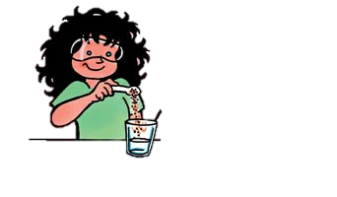Look at the information below then answer the questions that follow: (6 marks)

**Substance A**

**Substance A is dissolved in substance B.**

**Substance B**

1. What is substance A known as?

___________________________________________________________________________

1. What is substance B known as?

___________________________________________________________________________

1. What is the mixture of substances A and B known as?

___________________________________________________________________________

1. If only a small amount of substance A dissolved, how is the mixture described?

___________________________________________________________________________

1. If a large amount of substance A is dissolved, how is the mixture described?

___________________________________________________________________________

1. If the maximum possible amount of substance A is dissolved, what is the mixture described as?

___________________________________________________________________________

1. Filtration is used widely around the home and all around us.  
   Give two examples of filters used in every-day life. (2 marks)

FILTER A __________________________________________

FILTER B __________________________________________

1. Evaporation is a technique used to separate substances
2. What type substances would evaporation be used to separate? (1 mark)  
     
     
   ________________________________________________________________________
3. Can you give an example? (1 mark)  
     
     
   _________________________________________________________________________
4. Draw a scientific diagram showing evaporation separating substances.

(4 marks)

**END OF TEST**

**Please check your work!**